C PROGRAMS

SUBMITTED BY: SUBMITTED TO: NAME: SHIVYANSH DHIMAN MR. SHAMIK TIWAR

SAP ID: 500119671

C Program to Find Area and Circumference of Circle

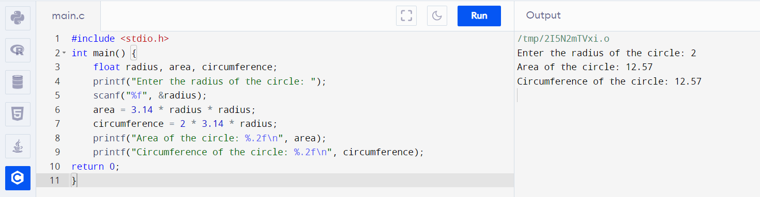

C Program to Find Area of Triangle Given Base and Height

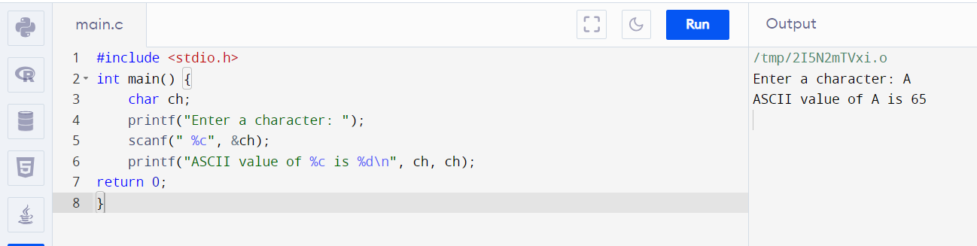

C Program to Find Area of Triangle Given Base and Height

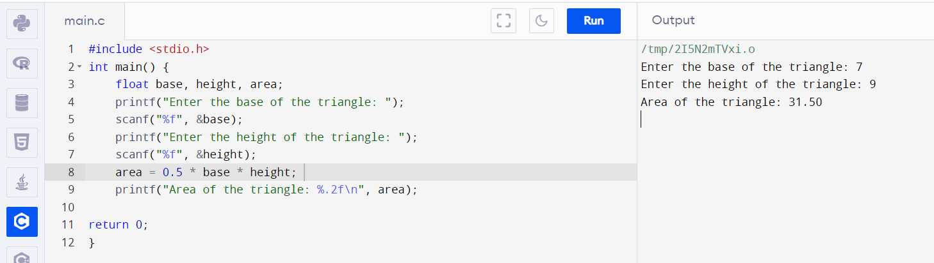

Calculate a Simple Interest

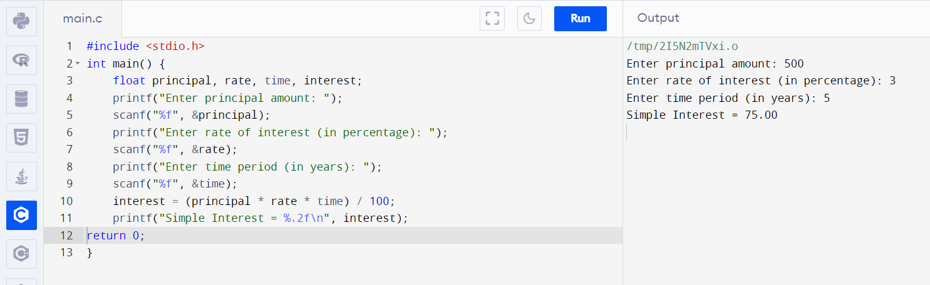

C Program to Find Percentage of 5 Subjects

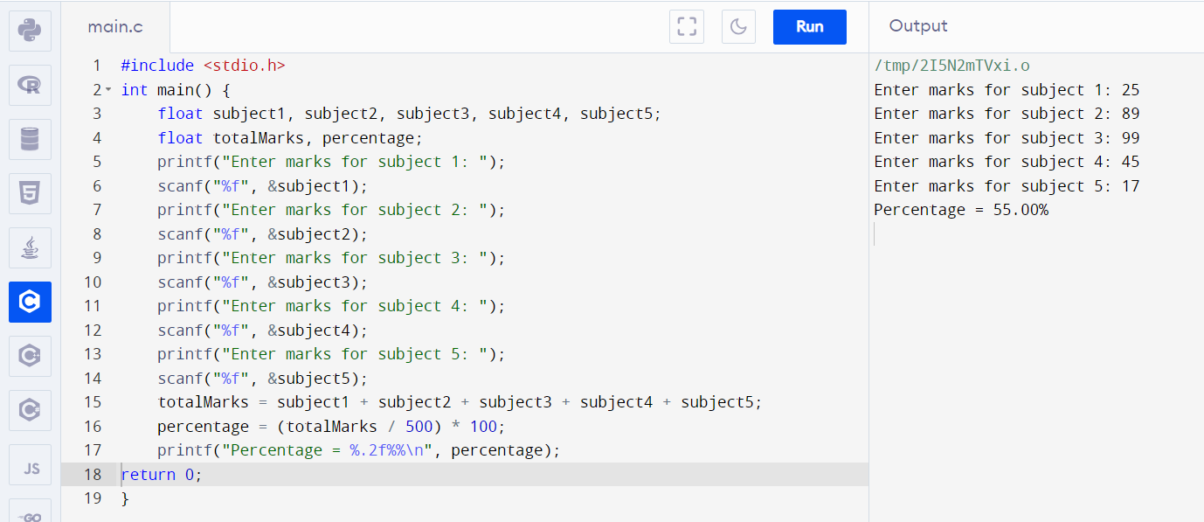

Convert Temperature Celsius into Fahrenheit

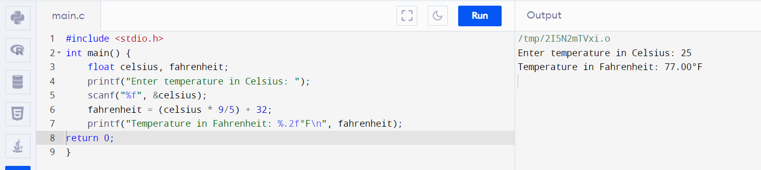

Check Number Is Positive or Negative

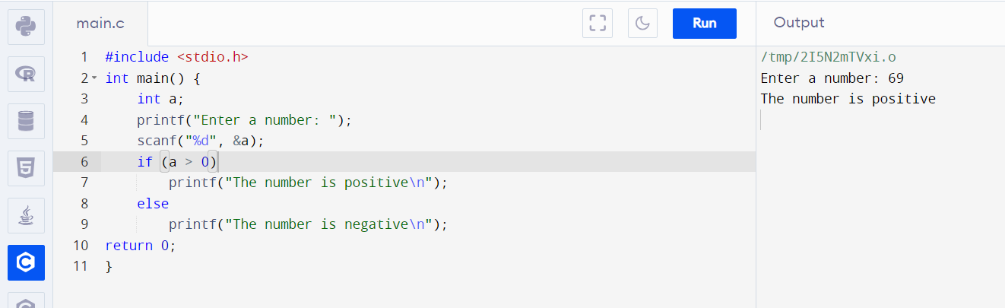

Find the Character Is Vowel or Not

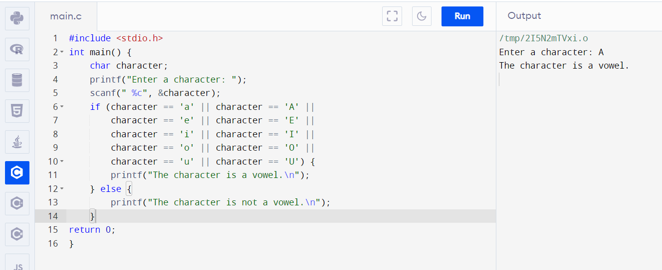

C Program to Read Integer and Print First Three Powers (N^1, N^2, N^3)

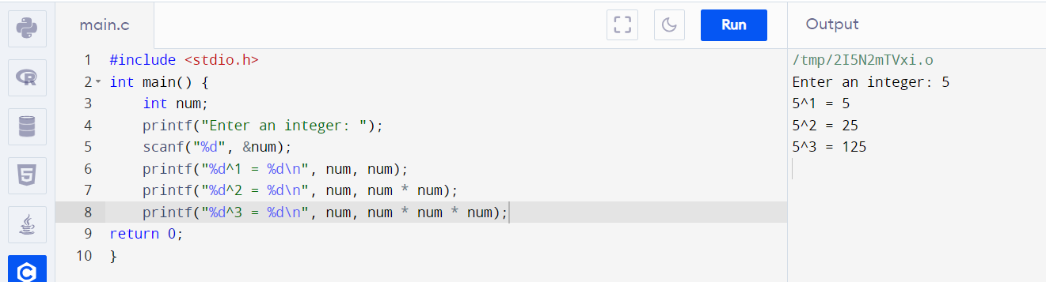

Program for Finding Greater Between Three Number

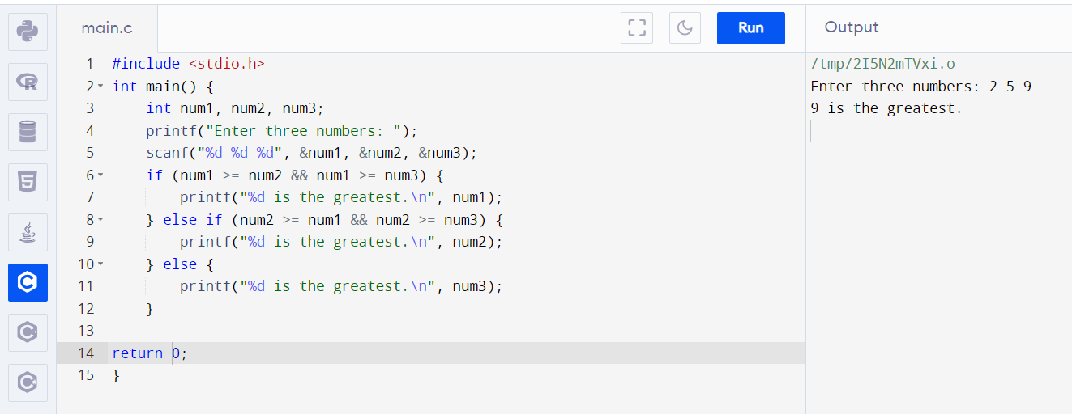

Checking Whether You Are Eligible for Voting or Not

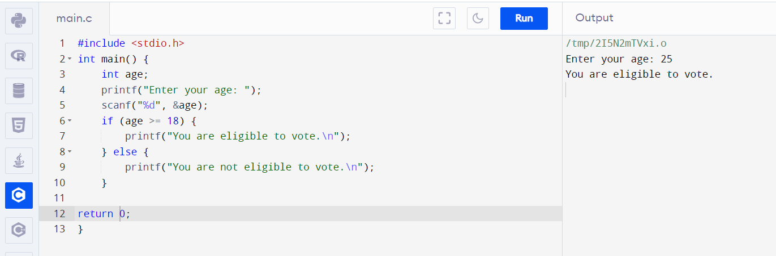

Program for Finding Greater Between Two Number

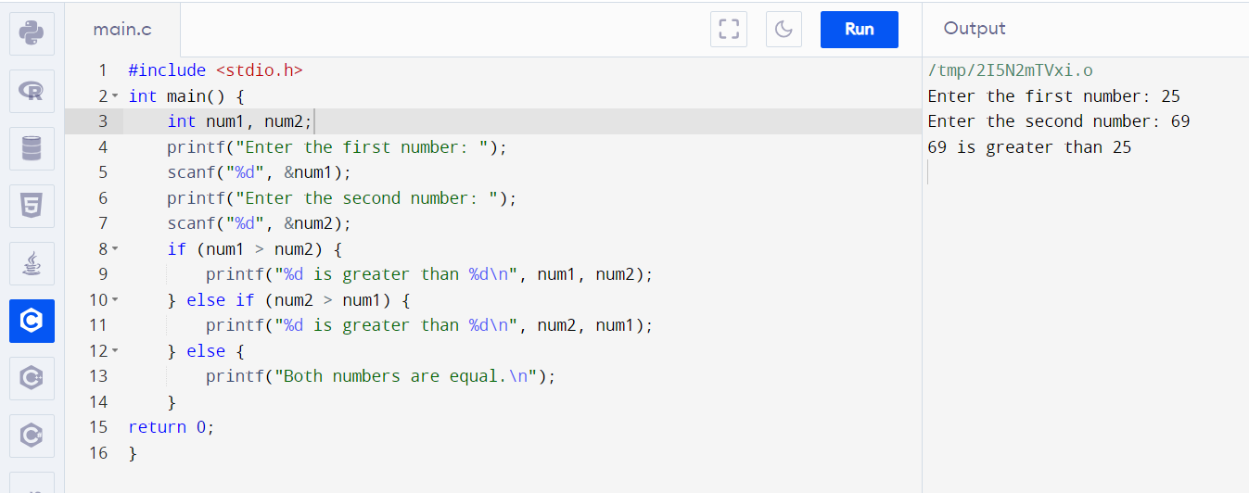

Checking Number Is Even or Odd

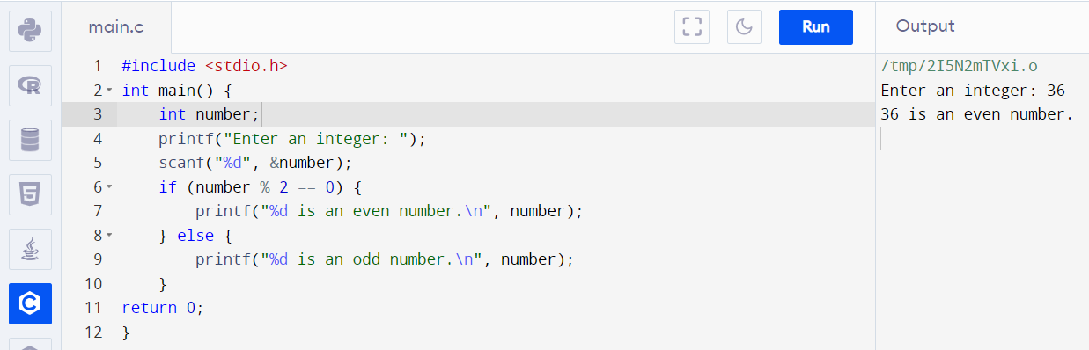

Leap year program

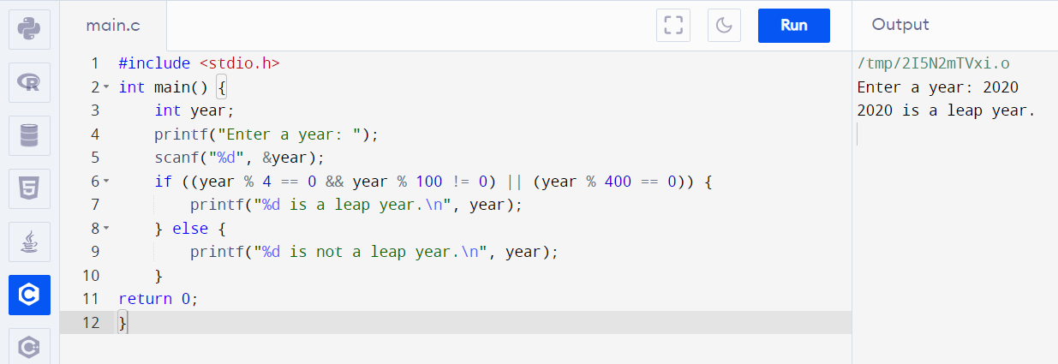

C Program to Reverse a Number Using FOR Loop

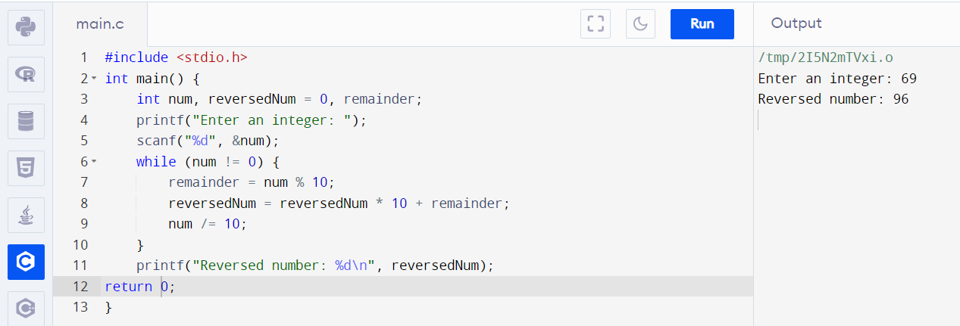

Program of Armstrong Number in C Using For Loop & While Loop

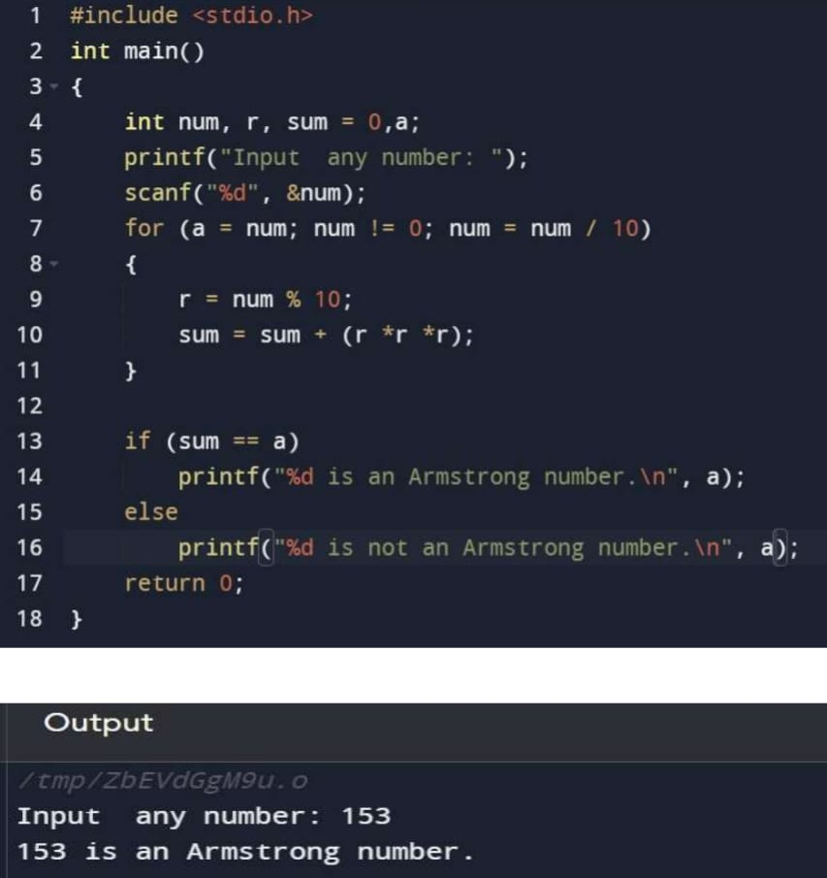

Calculate the Sum of Natural Numbers Using the While Loop

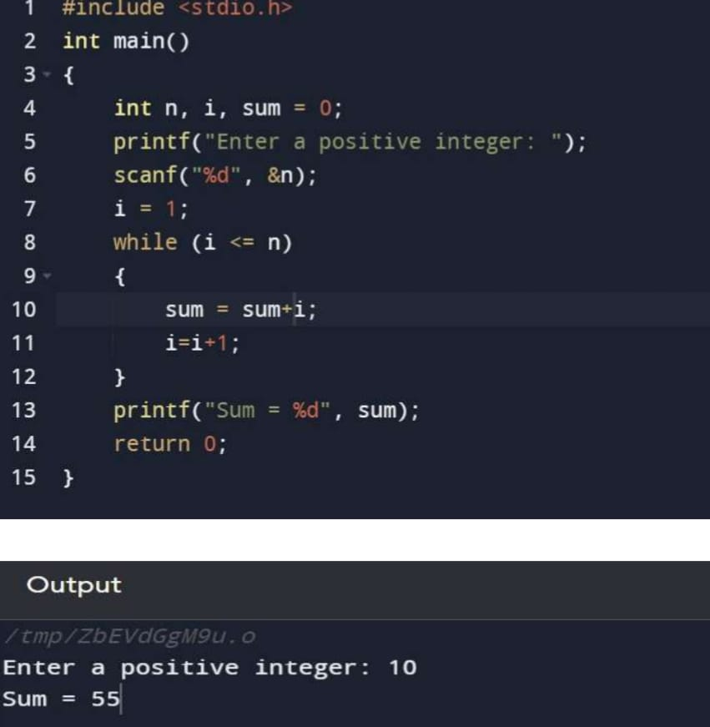

Write a C Program to Print the Multiplication Table of N

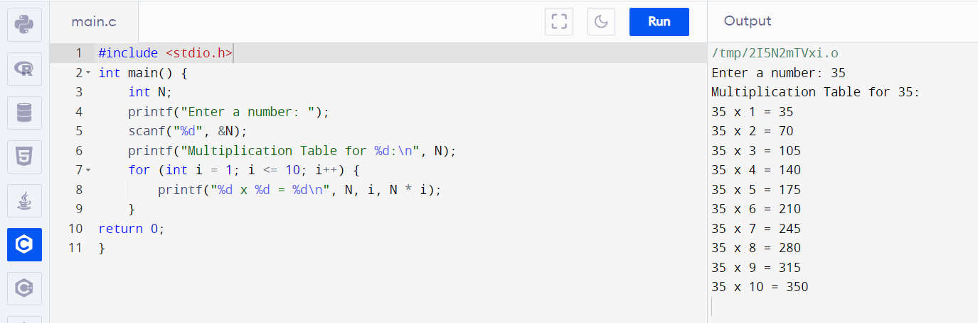

FIBONACCI SERIES

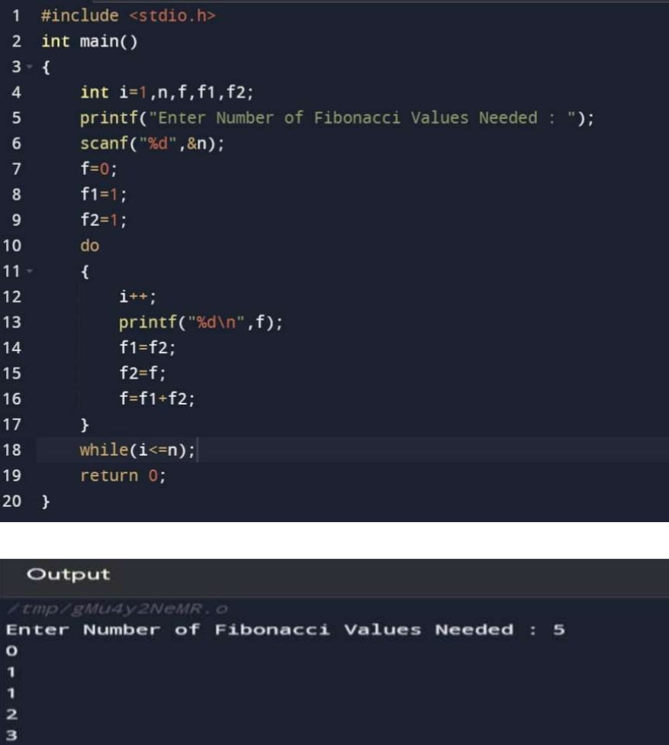

Find the GCD of Two Numbers Using Loop

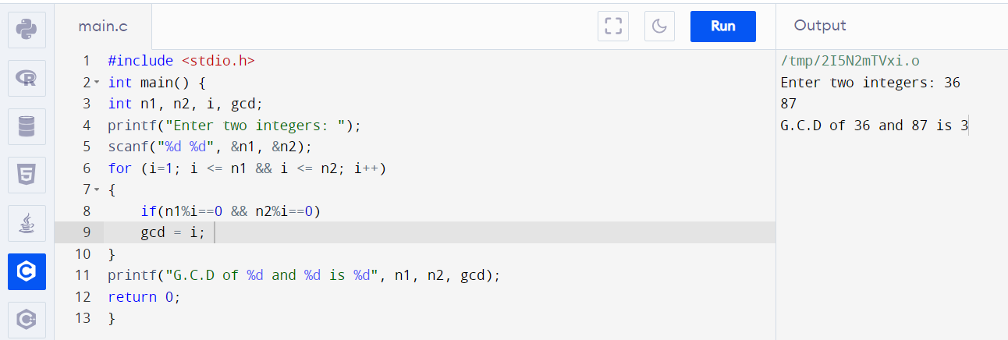

Program to Find LCM of Two Numbers in C Using While Loop

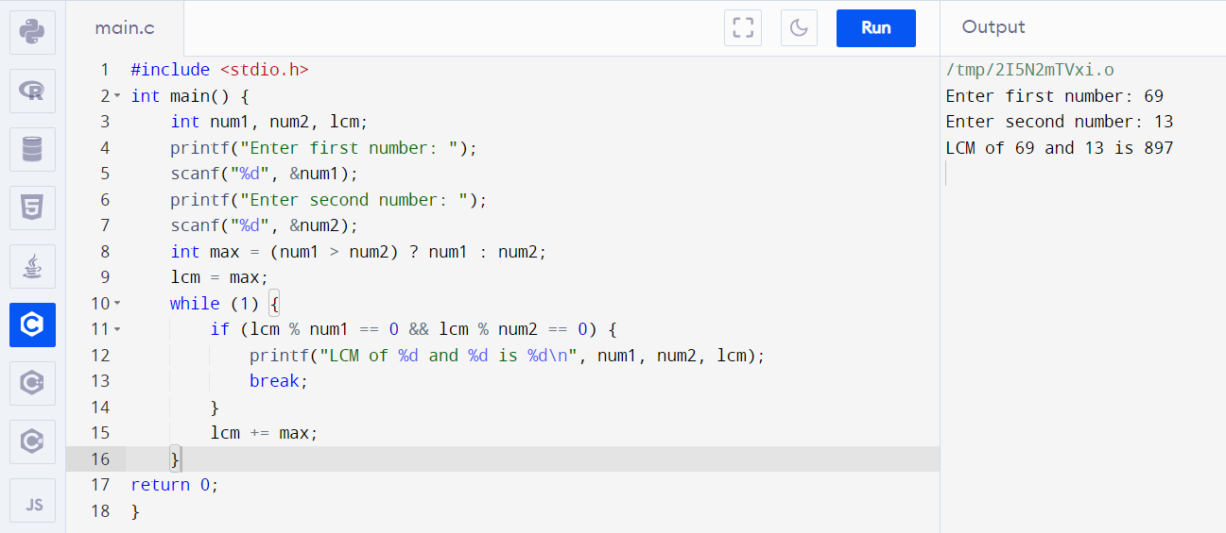

Palindrome

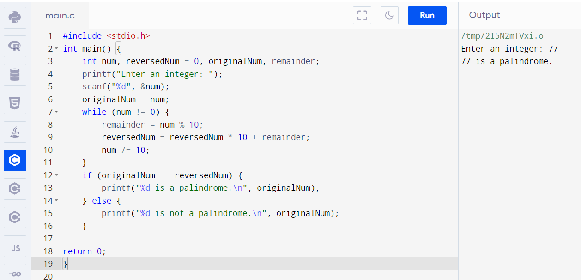

Count the Number of Digits of an Integer Using the While Loop

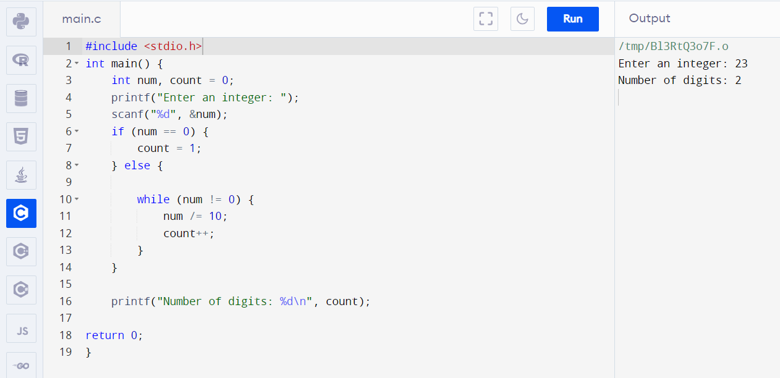

C Program to Print Day of Week Name Using Switch Case

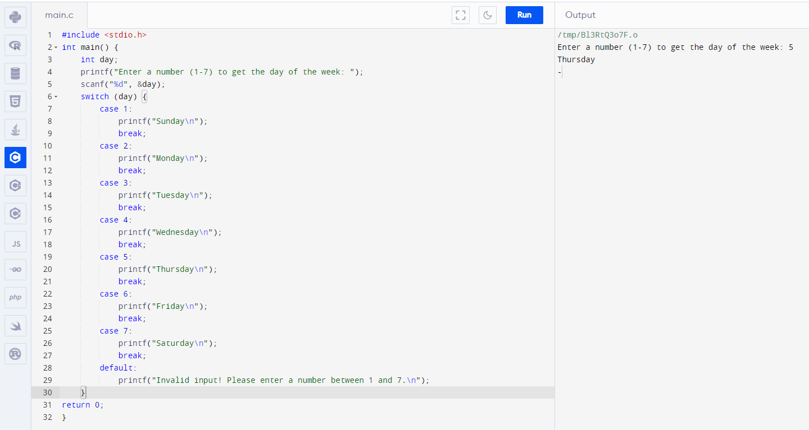

Write a C Program to Make a Simple Calculator Using Switch Case

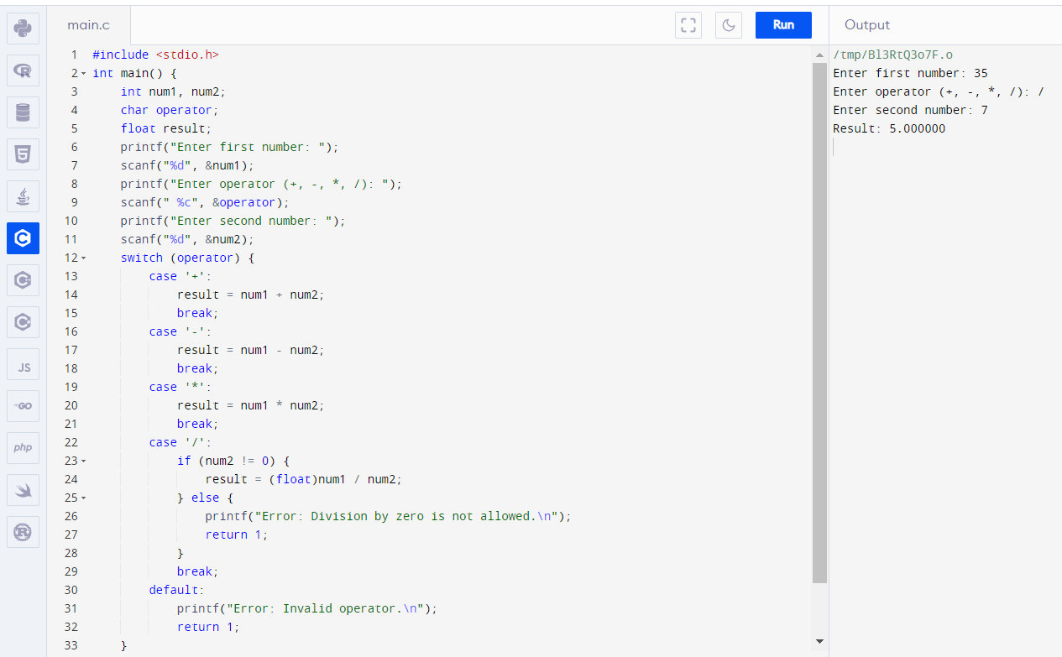

C program to find grade of a student using switch case

